Task No 01:

Write the following tasks in VVM Assembly Language program as well as VVM Machine Language format:

1. Take two inputs from the user and add them together, and then subtract the hardcoded value “5” from them.

Solution:

Output:

*Figure 1: Hardware View*

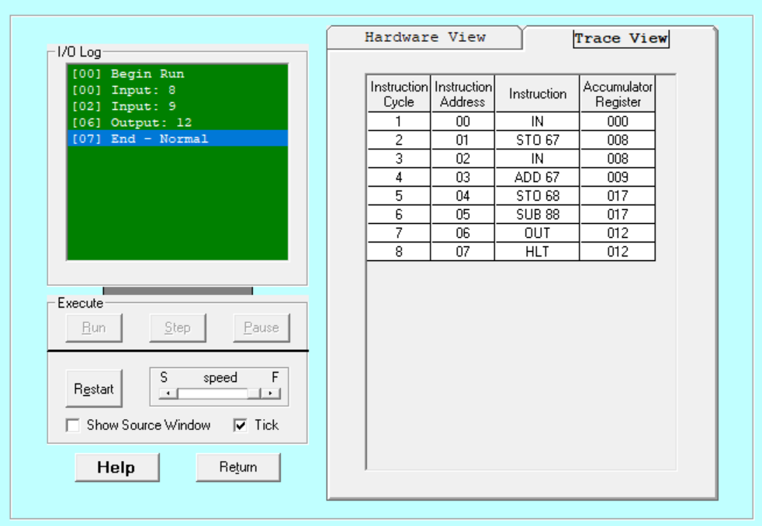

*Figure 2: Trace View*

1. Take three (any) hardcoded values and add them together.

Solution:

Output:

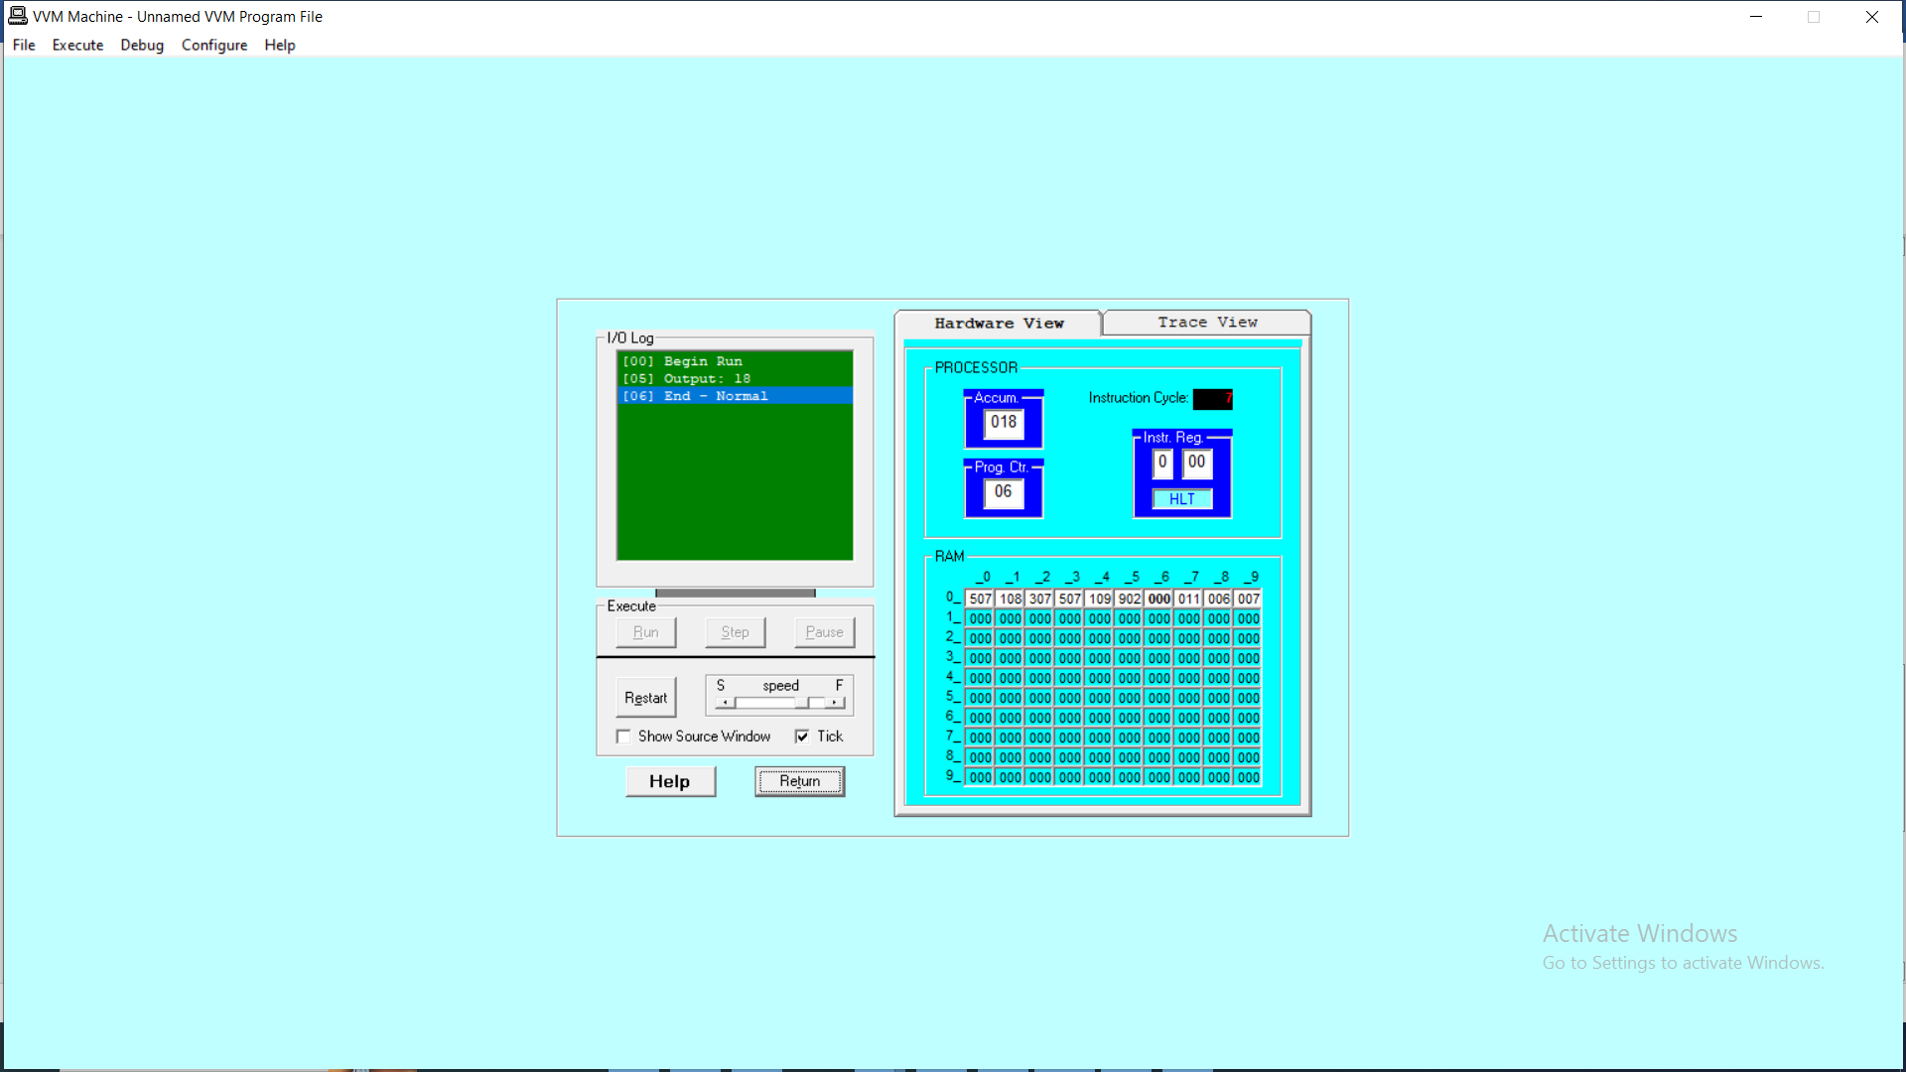

*Figure 1: Hardware View*

*Figure 2: Trace View*